INTRODUCTION:
Structural members that support compressive axial loads are called Columns. A column in structural engineering is a vertical structural element that transmits, through compression, the weight of the structure above to other structural elements below.
OBJECTIVE:
To determine the Column stability using boundary conditions, also to study behavior of different types of columns and find Euler’s buckling load for each case
THEORY:
In general if a beam element is under a compressive load and its length is an order of magnitude larger than either of its other dimensions such a beam is called columns. Due to its size its axial displacement is going to be very small compared to its lateral deflection called buckling.
The loads that are coming to column are more than the weight of the column the buckling factor takes place. A column can either fail due to the material yielding, or because the column buckles, it is of interest to the engineer to determine when this point of transition occurs.
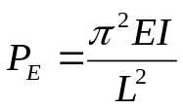Consider the Euler buckling equation

where L = Length of the Column (ft)
E = Young’s Modulus (Ksi)
I = Moment of Inertia (mm^4)
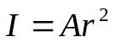Because of the large deflection caused by buckling, the least moment of inertia I can be expressed as
A is the cross sectional area
R is the radius of gyration.
The critical loads for the different sections given by
- Pinned-Pinned column buckling load for Length L = L
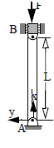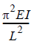
- Fixed-Fixed column buckling load for length L = (L/2)^2
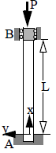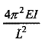

- Fixed-Pinned column buckling load for length L = (L/√2)^2
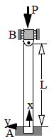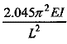
4) Fixed-Free column buckling load for length L= (L/2L) ^2
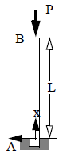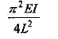

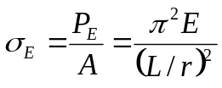Critical Column Stress:
Dividing the buckling equation by A, gives
σ_{E} is the compressive stress in the column and must not exceed the yield stress σ_{Y} of the material, i.e. σ_{E}<σ_{Y}, L / r is called the slenderness ratio, it is a measure of the column's flexibility
Critical Buckling Load:
P_{crit} is the critical or maximum axial load on the column just before it begins to buckle E Young’s modulus of elasticity
I least moment of inertia for the columns cross sectional area.
L unsupported length of the column whose ends are pinned
Input values given based on the condition:
- Young’s modulus: ___________( ksi)
- Area moment of inertia (I): _________ (mm^4)
- Length of column (L): ___________ (ft)
- Boundary conditions

Apparatus: -
Column Buckling Apparatus
Weights, Hanger
Dial Gauge
Scale
Verniar caliper
Lab Procedure: -
- Pin a graph paper on the wooden board behind the column.
- Apply the load at the top of columns increasing gradually. At certain stage of loading the columns shows abnormal deflections and gives the buckling load.
- Note the buckling load for each of the four columns.
- Trace the deflected shapes of the columns over the paper. Mark the points of change of curvature of the curves and measure the effective or equivalent length for each case separately.
- Calculate the theoretical effective lengths and thus buckling loads by the expressions given above and compare them with the observed values.

OBSERVATION:
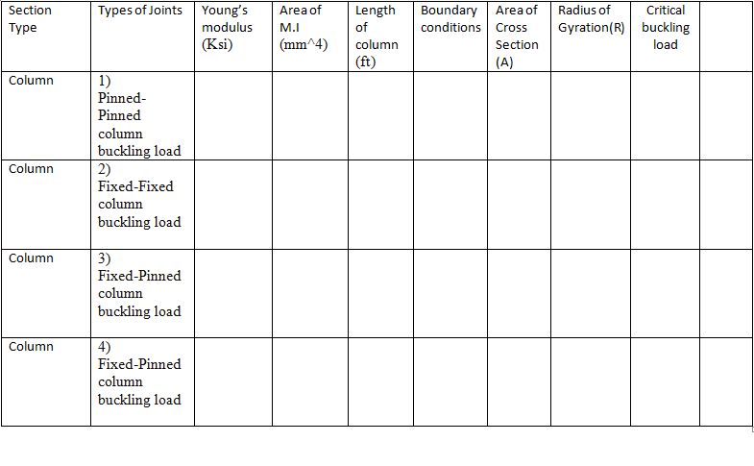
Sample Calculation: - End condition: Both ends fixed
Euler’s buckling load. = P = π² EI / l²
Effective Length (mm)
QUIZ:
- The buckling load formula for column?
- Number of boundary conditions that are present in columns
- What are the constant values that doesn’t change in calculation of Pcr

REFERENCES:
Mechanics of materials by Dr.B.C.punmia
Stability of columns by YI Nagornyi Prof
Design of steel structures by Prof.S.R.Satish Kumar and Prof A.R.Santha Kumar

PART – 2
ANIMATION STEPS
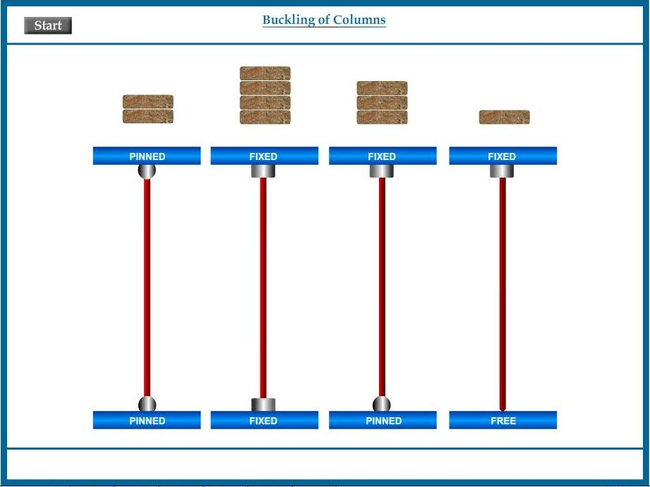

PART – 3
VIRTUAL LAB FRAME
